**All-In-One Counselling Management System**

**(Project Report)**

**Objective:**

The main objective of the counselling management system is to manage the details of counselling’s, results, registration and to guide users as professional to choose right career paths depending on their interests such as Academic, Career development, Personal counseling, etc. The project is totally built at administrative end thus only administrator is guaranteed the access. The purpose of the program is to build web based application program to reduce the manual type of works like get an appointment for consultant and managing the counselling’s details and so on.

**Features:**

* More secure Password protected, encrypted.
* Searchable database.
* Counselor enters days available.
* Provide the searching facilities based on various factors. Such as department vise.
* Application does have recommendation system that would be provide better counselor based on user’s reviews.
* Manage the all information from user portal and counselor portal.
* Admin can be track the all active users and counselors.
* Editing, adding and uploading of records is improved which results in proper resource management of counselling’s data.
* Also user can track the particular counselor locations to his/her the nearest current location.

**System Functionality:**

Login facility to the administrators is provided in order to manage the content of the system. The system function are more or less the same as described in the application perspective. The functions of the system include the system providing different type of services based on the type of users [Users/Administrator/Counselor].

* The Users should be able to view the second end counselor’s rankings on the bases recommendation system for each of the department.
* Users should be able to send queries and also get an answer from the counselor.
* The Admin is provided with a login id and password using which he should be able to login to the CCS.
* Administrator is provisioned to be able to manage the content of the system.
* The Administrator can view the registered users and also the traffic statistics i.e. the total number of visits to the system.

**Qualitative Results:**

* Flexibility and Convenience
* Connection to Counselors

**Functional Requirements:**

* Providing User the details of all competitive exams and other details.
* Enabling Users to post queries and respond to other’s queries using comments.
* Administrator login for administrators.
* Viewing of Traffic stats and User details by Administrator
* Managing of Content by Administrator.

**Non-Functional Requirements:**

* Backup of the database in case of failure.
* Security of the application to prevent attacks.
* Documents and comments throughout for up gradation.

**Users and Characteristics:**

The users of the system are student, accountant, business person etc. so the every person who want need an assist from counselor and the administrators who maintain the system. The administrators of the system to have more knowledge of the internals of the system and is able to resolve the small problems that may arise due to application failures and other related issue of the system. The proper user interface, user manual, online help and the guide to install and maintain the system must be sufficient to educate the users on how to use the system without any problems.

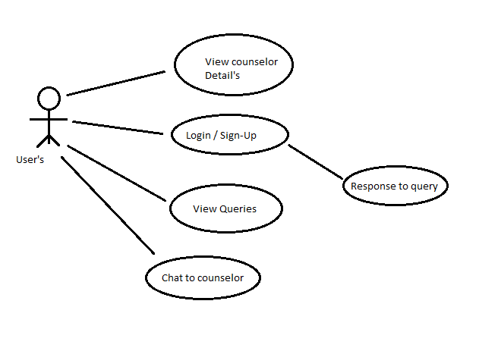**Use Case:**

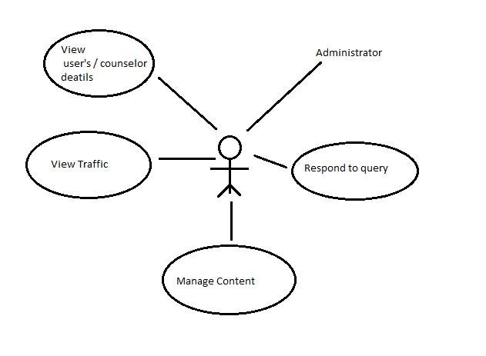**Administrator End:**

**Counselor End:**

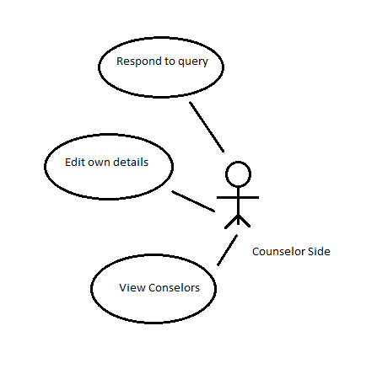

**Flowchart:**

**Users**

**Central Counselor**

**Online Counseling Intake Form**

**User Portal**

**Functional Requirements:**

* Type of users Admin, Users and Counselors.
* The admin is provided with a login id and password using which he should be able to login to the system.
* Admin can be track the all active users and counselors.
* The Administrator can view the registered users and also the traffic statistics i.e. the total number of visits to the system.
* System can have more than one admin.
* The administrators can be handle some activities like approval post, approval comments etc. ||
* User can be login into user portal.
* Counselor can be login into counselor portal.
* Users and counselors can be update his/her profile.
* User can subscribe to counselor.
* User can be respond on counselor post using comments.
* User can communicate to counselor via chat box.
* Counselors can post updates regarding different seminars and workshops.
* Provide the searching facilities based on various factors. Such as department vise.
* Also user can track the particular counselor locations to his/her the nearest current location.
* User can receive emails from the system.
* The administrator can be generate monthly report of system on the bases of major activities like how many users has been facilitate from counselors.
* More secure password protected, encrypted.

**Non-Functional Requirements:**

* Backup of the database in case of failure.
* Security of the application to prevent attacks.

**Additional Requirements:**

* User can communicate to counselor via voice call.